

**Topic : Tableau Dashboard**

**“Covid-19 Dashboard”**

Name : Rishav Kumar

Reg No. : 12221177

Roll No. : 30

Section : K22CA

Submitted To : Maneet Kaur Ma’am

# DECLARATION

I hereby declare that the project work entitled " **Analysis of Covid-19 dataset for India** " is an authentic record of our own work carried out as requirements of Project for the award of B.Tech degree in **Computer Science and Engineering from Lovely Professional University, Phagwara** under the guidance of **Maneet Kaur**, LPU during August to November 2024. All the information furnished in this project report is based on our own

intensive work and is genuine.

Name of Student: RISHAV KUMAR Registration Number: 12221177

Date: 15/11/2024

# Introduction

The Tableau Workbook analyzes COVID-19 data, including infection rates, vaccination progress, and testing metrics. The data sources cover various dimensions such as geographical boundaries, age demographics, and

vaccination details. The purpose of the analysis is to visualize trends and patterns to assist in decision-making and policy formulation.

# Scope of the Analysis

**1. COVID-19 Case Trends Across Regions in India**

This metric tracks the progression and patterns of COVID-19 cases across states and districts in India.

* **Key Insights:**
  + **Temporal Trends:** Analyze daily, weekly, or monthly case counts to identify spikes, declines, or stable periods.
  + **Regional Analysis:** Pinpoint regions with high infection rates to focus interventions like lockdowns or medical aid.
  + **Hotspot Identification:** Detect clusters or outbreak zones for containment measures.
* **Visualization Techniques:**
  + **Line Charts:** Show trends over time.
  + **Heat Maps:** Highlight infection density across states or districts.
  + **Interactive Dashboards:** Allow users to filter by state or date range for specific insights.

**2. State-wise and Age-group-wise Vaccination Data**

This metric tracks the progress of vaccination efforts across states, broken down by age groups.

* **Key Insights:**
  + **State-level Coverage:** Identify states with the highest and lowest vaccination rates.
  + **Age-group Analysis:** Evaluate vaccination coverage in vulnerable groups (e.g., senior citizens or adolescents).
  + **Dose-specific Trends:** Compare first and second dose administration rates.
* **Visualization Techniques:**
  + **Bar Graphs:** Compare vaccination rates across states or age groups.
  + **Pie Charts:** Show proportions of vaccinated individuals in different demographics.
  + **Maps:** Geographically represent vaccination coverage.

**3. Testing Infrastructure and Capacity**

This metric focuses on the availability, location, and capacity of testing centers managed by the Indian Council of Medical Research (ICMR) and others.

* **Key Insights:**
  + **Facility Distribution:** Determine the geographical spread of testing labs to identify underserved regions.
  + **Testing Volume:** Monitor daily or cumulative testing numbers to ensure sufficient capacity.
  + **Utilization Rates:** Assess whether existing labs are operating at optimal capacity.
* **Visualization Techniques:**
  + **Geospatial Mapping:** Plot testing centers on a map for visual analysis.
  + **Cluster Analysis:** Identify regions with high or low testing availability.
  + **Bar Charts:** Show capacity and utilization comparisons across facilities.

**4. Geographical Representation of Key COVID-19 Metrics**

Geospatial mapping enables a visual representation of various COVID-19 metrics, such as cases, vaccinations, and testing, across India's regions.

* **Key Insights:**
  + **Spatial Trends:** Understand the geographical spread of infections or resource distribution.
  + **Regional Disparities:** Highlight regions with resource deficits, such as testing labs or vaccine centers.
  + **Overlay Analysis:** Combine multiple metrics (e.g., cases vs. testing centers) for deeper insights.
* **Visualization Techniques:**
  + **Choropleth Maps:** Use color coding to show case density, vaccination rates, or testing coverage.
  + **Point Maps:** Represent specific locations like testing labs or vaccination centers.
  + **Interactive Layers:** Allow users to toggle between different metrics for comparison.

**5. Identification of Future Trends and Actionable Insights**

Using historical data and visualization tools, the system identifies patterns that may signal future developments.

* **Key Insights:**
  + **Prediction of Surges:** Use trends in testing, vaccination, and cases to forecast potential outbreaks.
  + **Resource Planning:** Identify future needs for testing kits, vaccination doses, or healthcare infrastructure.
  + **Policy Recommendations:** Support decision-making for targeted interventions like localized lockdowns or vaccination drives.
* **Visualization Techniques:**
  + **Trend Lines:** Project future case numbers or vaccination rates using historical data.
  + **Scenario Modeling:** Simulate outcomes under different assumptions (e.g., increased testing rates).
  + **Dashboards:** Present insights in a consolidated format for real-time decision-making.

# Existing System

The existing system uses multiple datasets from various sources to visualize:

* + COVID-19 case data (covid_19_india).
  + Testing data by state (StatewiseTestingDetails).
  + Vaccination statistics (covid_vaccine_statewise).
  + Geographical boundary mapping (India_State_Boundary).
  + Testing facilities managed by ICMR (ICMRTestingLabs).

The workbook integrates these datasets into worksheets and a dashboard, facilitating visual exploration and trend analysis.

# Source of Dataset

The dataset used for this project is sourced from Kaggel and github all the data are provided give the exact figures about covid-19 in India.

1. **ETL (Extract, Transform, Load) Process in Tableau:**

The **ETL process** involves three key stages: **Extract**, **Transform**, and **Load**. In Tableau, these steps are primarily performed through its **data connection and preparation mechanisms** before visualizations are created. Below is a detailed explanation of each step in the Tableau context:

**1. Extract**

This is the stage where Tableau connects to data sources and pulls the data required for analysis.

* **Supported Data Sources:** Tableau supports a wide range of sources including relational databases (e.g., SQL Server, MySQL), cloud platforms (e.g., Salesforce, AWS Redshift), flat files (e.g., Excel, CSV), and more.
* **Data Extraction Methods:**
  + **Live Connection:** Tableau queries the source in real-time. This is useful when you need up-to-date data, but it may affect performance.
  + **Extract Connection:** Data is imported and stored locally in Tableau’s proprietary format (.hyper file). This improves performance and allows offline analysis.
* **Purpose:** The goal is to pull raw data into Tableau from one or multiple sources, ensuring it is ready for further processing.

**2. Transform**

At this stage, Tableau allows you to clean, reshape, and prepare the data for analysis. This ensures the data is structured and formatted for effective visualization.

**Key Transformation Actions in Tableau:**

* **Data Cleaning:**
  + Handle missing values by replacing them with default values, excluding them, or flagging them.
  + Remove duplicate rows to maintain data integrity.
  + Filter unnecessary rows or columns to focus only on relevant data.
* **Combining Data:**
  + **Union:** Combine multiple tables with similar structure (e.g., appending quarterly sales data files into one dataset).
  + **Joins:** Merge data from multiple tables using common fields like Customer_ID or Order_ID.
  + **Blending:** Combine data from unrelated sources (e.g., blending sales data from a database with weather data in a flat file).
* **Renaming Fields:** Rename field names to make them user-friendly and relevant for visualization (e.g., renaming cust_id to Customer ID).
* **Defining Calculated Fields:**
  + Create custom fields using Tableau's calculation syntax (e.g., Profit = Sales - Cost).
  + Use conditional expressions (IF statements) or aggregation functions (e.g., sum, average).
* **Pivoting and Reshaping:** Convert columns into rows or vice versa to align the structure of the data with visualization needs.

**Tools:** Tableau Desktop includes features like Data Interpreter, Calculated Fields, and Pivot to make transformations intuitive.

**3. Load**

Once the data has been cleaned and transformed, it is ready to be loaded into Tableau for visualization.

* **Data Storage in Tableau:** Tableau stores the transformed data as a temporary dataset in memory (live connection) or as an extract file (offline analysis).
* **Load into Worksheets:**
  + The processed data is loaded into Tableau’s **Data Pane**.
  + From here, fields can be dragged and dropped onto the **Rows**, **Columns**, and **Marks** shelves to create visualizations.
* **Real-time Updates:** If a live connection is used, Tableau continues to fetch and update data in real-time.
* **Visualization Preparation:**
  + Choose appropriate chart types (e.g., bar charts, line graphs, maps).
  + Create dashboards or stories combining multiple visualizations.

**SNAPSHOTS OF DASHBOARD**

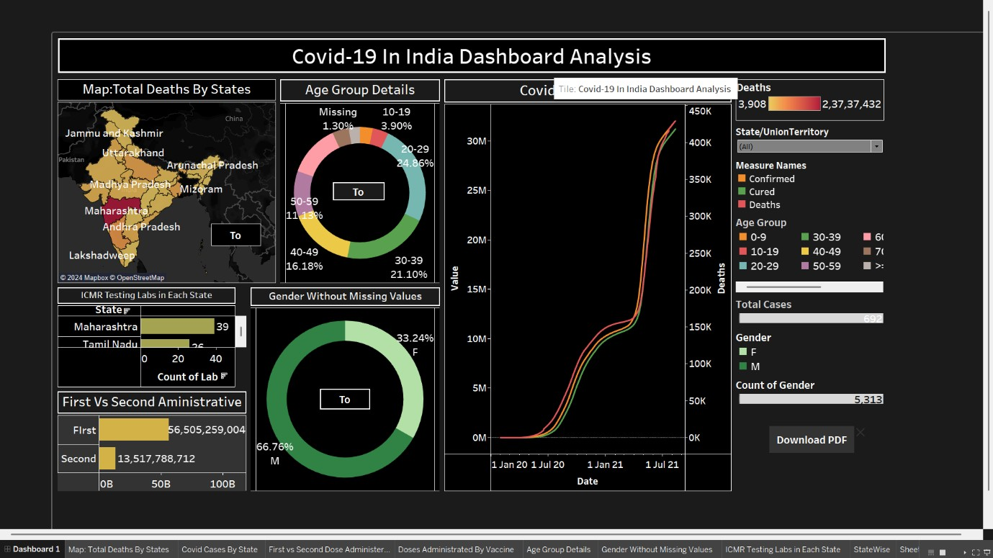

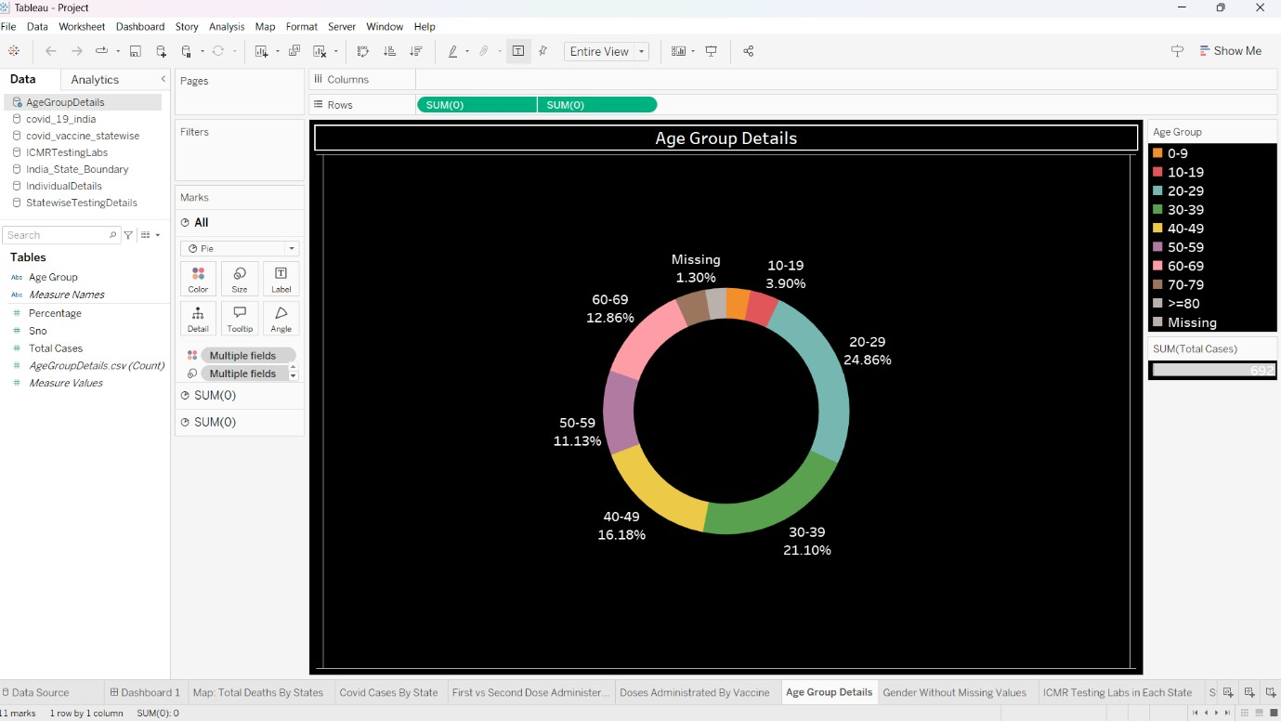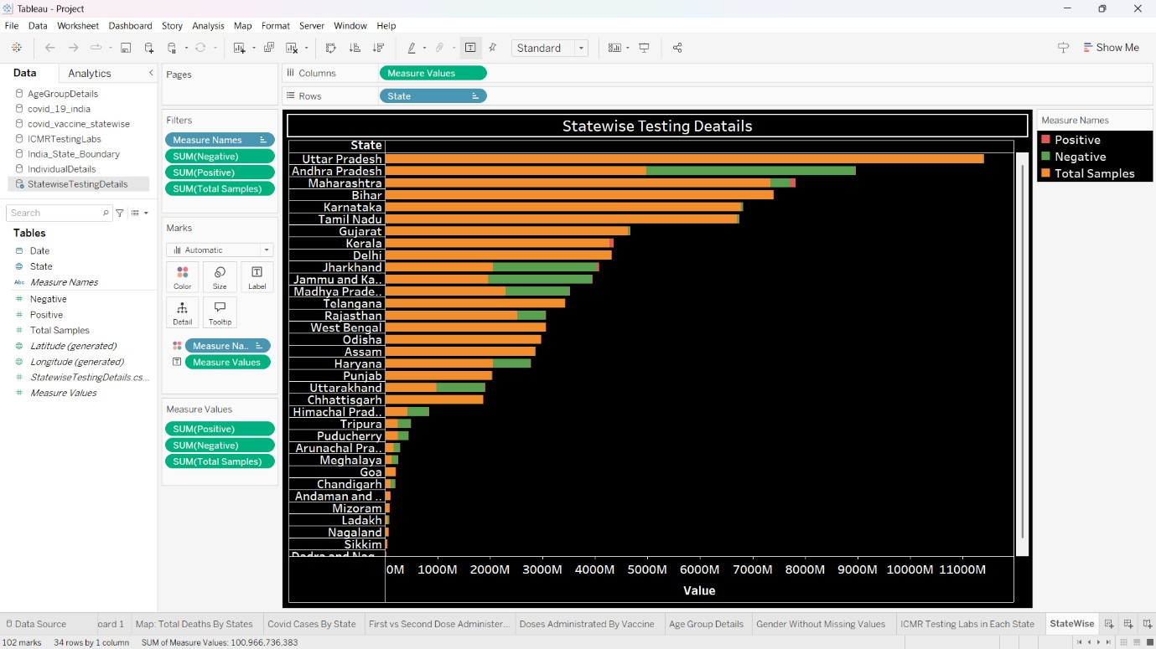

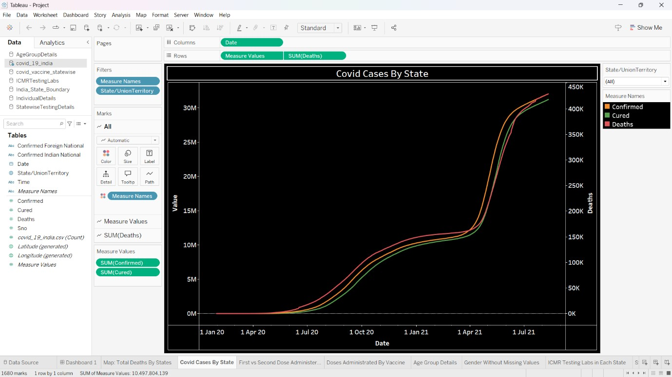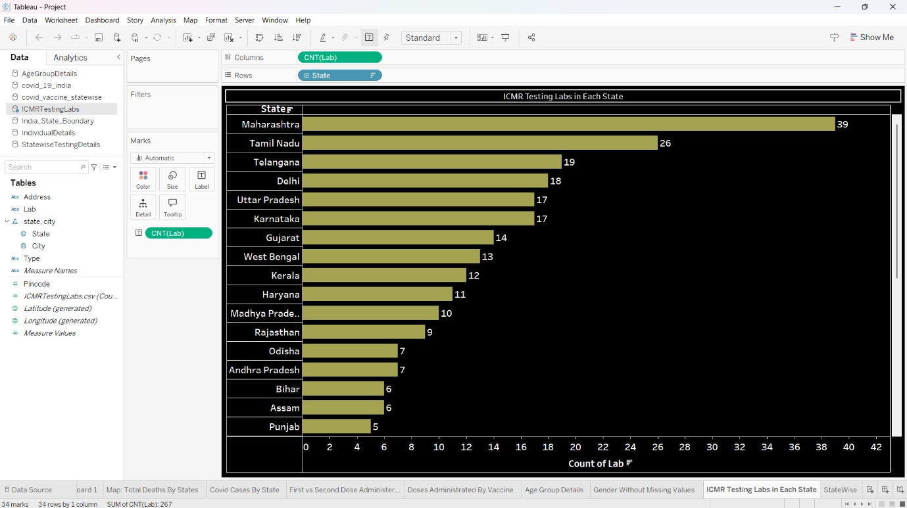

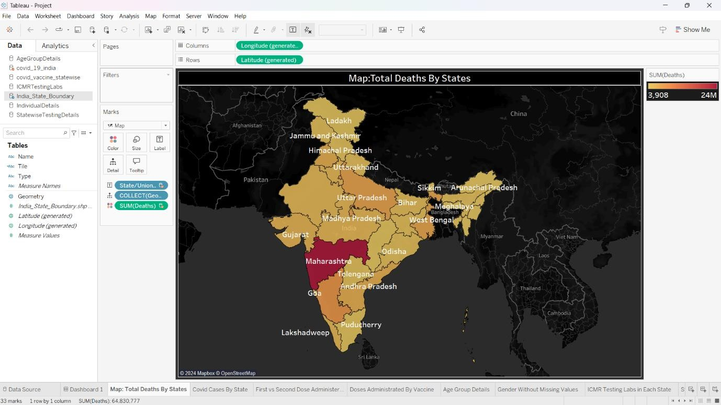

**Conclusion: Integration and Visualization of Multi-source COVID-19 Data in Tableau**

The integration of multiple datasets into Tableau demonstrates a robust and comprehensive approach to visualizing and analyzing COVID-19-related data. By leveraging diverse data sources, the system provides a detailed and interactive platform for tracking, understanding, and interpreting key trends in the pandemic's progression and response efforts. The following highlights summarize the overall process and its value:

**1. Comprehensive Data Integration**

The system combines data from a variety of sources, each providing unique insights into different aspects of the pandemic:

* **COVID-19 Case Data (covid_19_india):** Tracks the spread and intensity of infections across India, offering granular information for historical and current trends.
* **Statewise Testing Data (StatewiseTestingDetails):** Highlights the testing volume and patterns, enabling users to assess the testing efficiency and reach across states.
* **Vaccination Statistics (covid_vaccine_statewise):** Details the progress of vaccination campaigns, including doses administered, state-level achievements, and demographic distributions.
* **Geographical Mapping (India_State_Boundary):** Provides spatial context to the data, allowing for geospatial analysis of trends like infection hotspots and vaccination coverage.
* **ICMR Testing Facilities (ICMRTestingLabs):** Offers insights into the infrastructure and accessibility of testing centers managed by the Indian Council of Medical Research (ICMR).

**2. Unified Visualization in Tableau**

The integration of these datasets into Tableau worksheets and a dashboard ensures that all the critical metrics and patterns are brought together in a unified visual interface. This approach enhances the ability to explore relationships and dependencies between data points, such as:

* Comparing infection rates with testing and vaccination efforts at state and national levels.
* Visualizing the geographical distribution of cases, testing labs, and vaccination centers to identify underserved areas.
* Monitoring real-time or near real-time updates for dynamic decision-making.

**3. Facilitating Data-driven Decision-making**

The visual exploration and trend analysis capabilities provided by the Tableau workbook empower stakeholders, such as government officials, public health experts, and researchers, to make informed decisions. The benefits include:

* Identifying trends in infection spread and correlating them with testing and vaccination efforts.
* Pinpointing gaps in testing infrastructure or vaccination outreach to reallocate resources effectively.
* Enabling a more nuanced understanding of regional disparities through geospatial mapping.

**4. Enhanced User Experience and Insight Accessibility**

The interactive dashboard created in Tableau ensures that even non-technical users can engage with the data. Features like filters, drill-down capabilities, and dynamic charts make it easier to focus on specific regions, timeframes, or data categories.

**THANK YOU**